

ITA0324-Mobile Computing

Name: A. Anusha Reg no:192472083

Slot: C Course Name: Mobile Computing

Experiment 11: Mobile Application with Security Measures
Aim: To design a wireframe for a mobile application incorporating security measures using Figma.
Procedure:
- Open Figma and create a new design file.
- Select a smartphone frame for the security application.
- Design a login screen with username and password fields.
- Add OTP verification and biometric authentication options.
- Include password visibility and privacy settings.
- Add security alerts and account protection options.
- Use Prototype mode to connect the screens and test the navigation flow.

Output:
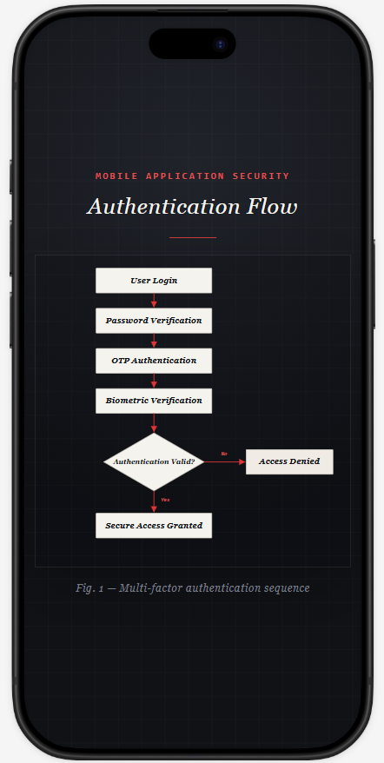
Result: Thus, a secure mobile application wireframe incorporating authentication and privacy features was designed successfully using Figma.

